How to add a plugin in Fusion

1. Unzip the file received from Excellence Center (file which contains signed plugin) or copy the Debug/Release folder of your Visual Studio project in the folder ***C:\Program Files (x86)\Desoutter\CVI Fusion\InfinityPlugins***

You must have 1 folder per plugin

1. Open CVI Fusion
2. Create a new plugin step. In the plugin name list, you must see the name of your plugin.

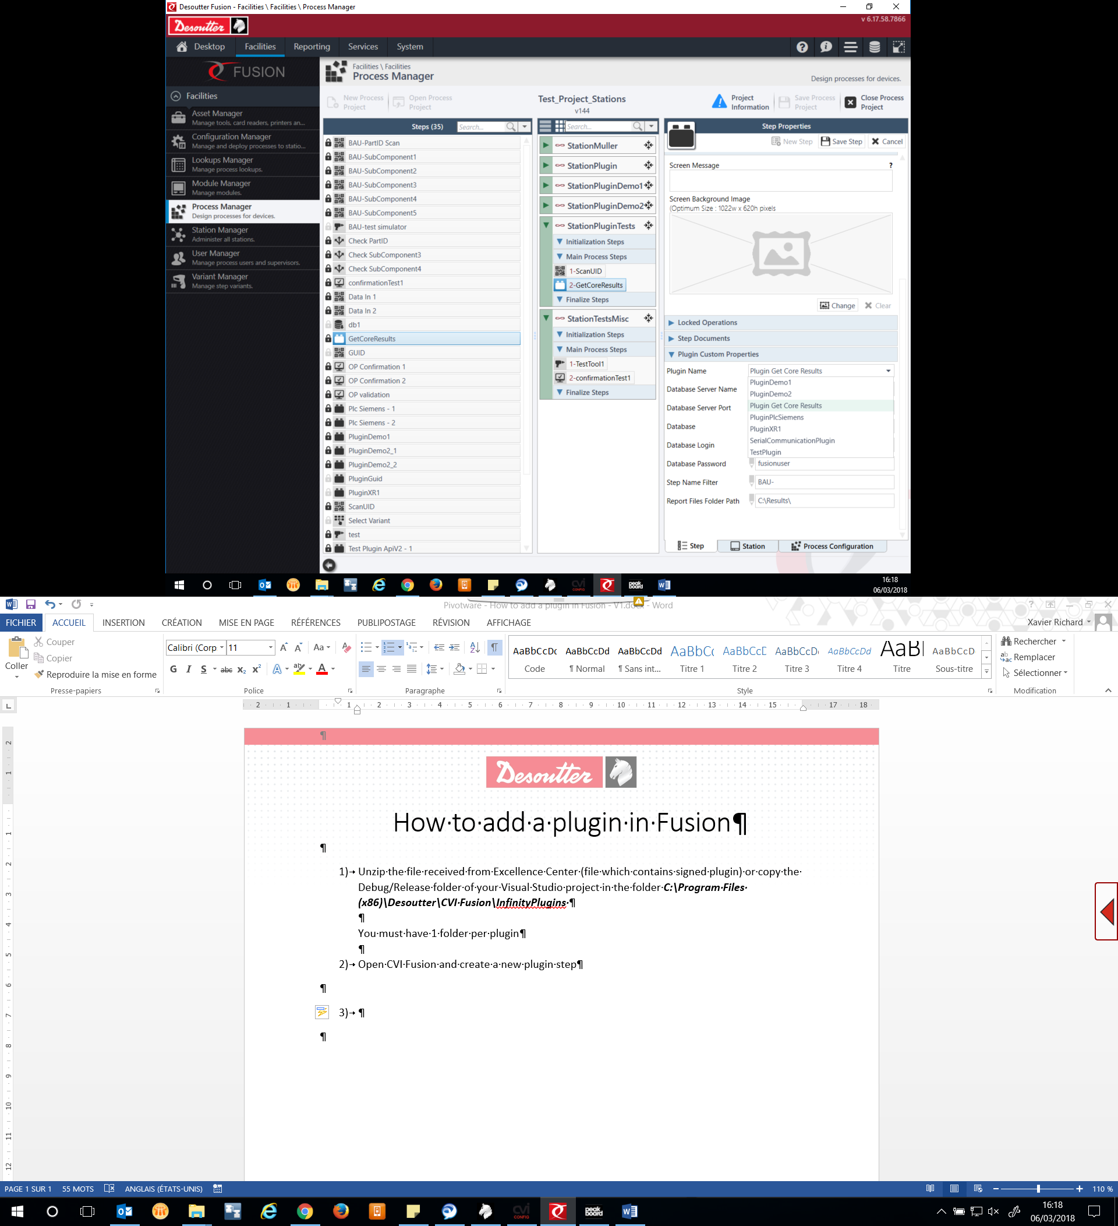

1. Select your plugin and complete the plugin parameters fields

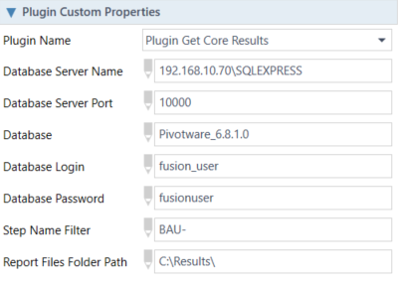

1. Save the step, place your step in a process then deploy your configuration in the station.